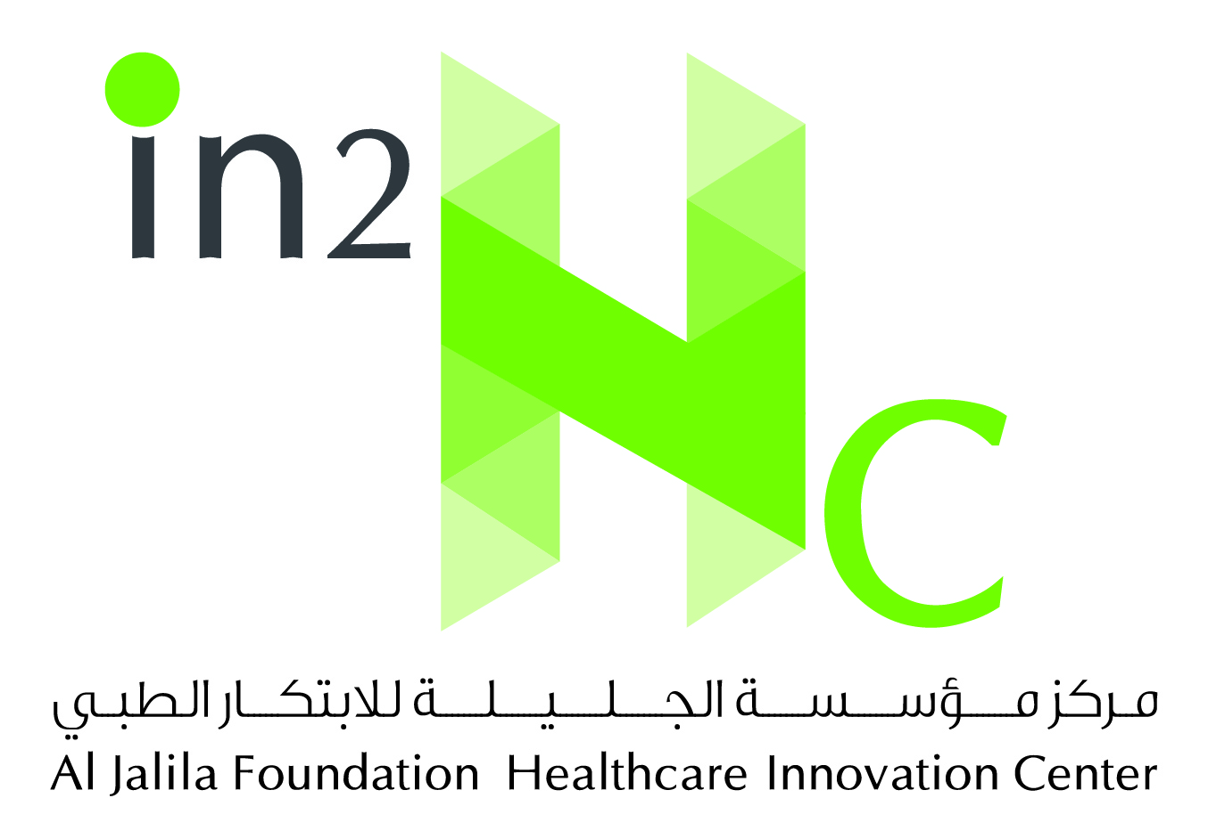

AL JALILA FOUNDATION HEALTHCARE INNOVATION CENTER (in2Hc)
APPLICATION FORM

Please type-in all information requested in this form and send it - along with the documents listed on the last page of this form - to in2Hc@aljalilafoundation.ae
APPLICANT PERSONAL DETAILS
Full Name:
Gender:
Date of Birth:
Marital Status:
Emirate of Residency:
UAE Passport Number:
UAE Nationality Document (Khulasat AlQayd) Number:
UAE ID Number:

CONTACT DETAILS
Mobile Number 1:
Mobile Number 2:
Facsimile Number:
E-mail:
PO. Box & Emirate:
Full Home Address:

Briefly describe your healthcare business concept and the target audience. In other words, what is your business idea and who will be your customers (in no more than 300 words)

Medical License Registration (Most Recent First):

Full name of Licensing/Registration Jurisdiction | License Registration Category | License Registration Number | License Issue Date | License Expiration Date | License Registration Status (Active, Inactive, Suspended, or Revoked)

Medical College / University (Most Recent First): Please List all Medical College/University Attended after Obtaining High School/Secondary Education Diploma/Certificate

Full Name of College/University | Country | Degree /Qualification Obtained | AGPA | Attended from | Attended to | Graduation Date

Post Graduate Education: List all Postgraduate Medical Education Obtained after Graduation from College/University. These include Internship, Supervised Clinical Training, Residency, Masters etc.
Specialty Training Program | Name of Institute/Hospital | Qualification/Residency Obtained | Attended from | Attended to | Completion Date

Complete Employment History (Most Recent First):

Date from | Date to | Position | Department | Organization | Country

Specialty Board or Equivalent : List Specialty Board Certification Obtained After Completing the Post Graduate Medical Education
Name of Specialty Board | Board Identification Number | Date Certification Obtained | Address

Professional Membership/Affiliations : Summary of Professional Membership/Affiliation
Full Name of Institution/association | Date from | Date to | Address

REFEREES
Name | Occupation | Organization | Telephone | Email | Briefly Indicate How you Know this Person

REQUIRED DOCUMENTS
Please attach all of the following documents to complete your application:
- Al Jalila Foundation Healthcare Innovation Center (in2hc) Application Form
- Curriculum Vitae
- Copy of Emirates ID
- Copy of Passport
- Copy of UAE Nationality Document (Khulasat AlQayd)
- Copy of Medical Degree Certificate (if obtained from a private academic institution, a copy of the attested degree is required)
- Medical College/University Transcripts
- Speciality Board Certificates (if the applicant has it)
- Residency/Training Letters (proof of postgraduate medical education from institute/hospital)
- Medical License Registration and Certificate of Good Standing from Licensing Authority

I hereby confirm that the information and documentations presented are true and correct to the best of my knowledge.

Full name (Applicant): __________________ Date of Submission: _____________________

Please be advised that the approval of this application will be subject to DHCC-CPQ Licensing approval.

For inquiries, please email us on in2hc@aljalilafoundation.ae

