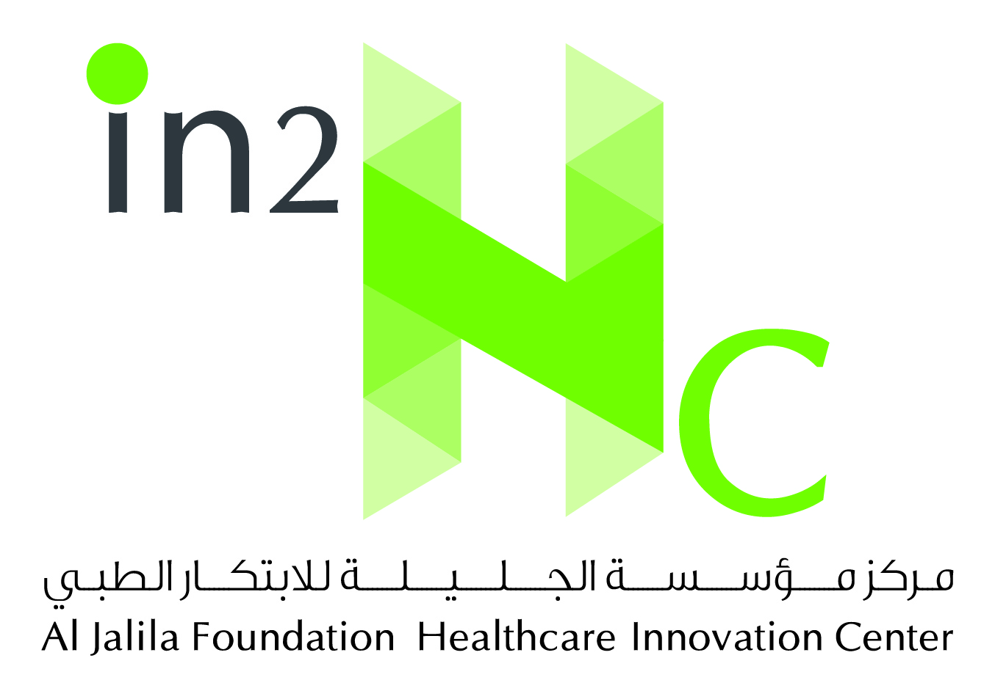
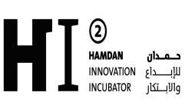

Al Jalila Foundation Healthcare Innovation Center (in2Hc)
Frequently Asked Questions
Question: What is the objective of establishing in2Hc?
Answer: in2Hc aims to enable Emirati physicians to startup their healthcare project (mainly clinics) at the Dubai Healthcare City by providing them with the incubation facilities including medical and business support.
After the incubation period, the Emirati physician will transfer his/her established project to any other location in the UAE in order to run it independently.
Question: Will in2Hc accept proposals from all medical specializations?
Answer: Yes, except for dentistry for the time being. The proposed specializations will be discussed with the Emirati physician after receiving the application with all required documents.
Question: Where is the in2Hc located?
Answer: At Dubai Healthcare City.
Question: I am an Emirati healthcare professional and would like to start up my business at in2Hc. Can I apply, although my business idea is not in the form of a clinic?
Answer: Yes you can apply by submitting the application form and all related documents. The in2Hc team will review your application and contact you to inform you of the next steps.
Question: What type of commitments does the Emirati Physician have to give during the incubation period?
Answer: He/she will be required to attend his/her in2Hc project regularly, meet the in2HC team, provide monthly reports, and meet his/her financial commitments.
Question 6: Does the Emirati physician have to attend his/her in2Hc project on a full time basis?
Answer: He/she can attend his/her in2Hc project on a full or part time basis, as long as he/she shows adequate dedication to enable the project to succeed and endure.
Question: For how long can the Emirati physician stay in the in2Hc incubator?
Answer: For two years, and can be extended to one additional year, depending on the performance of his/her project.
Question: Can the Emirati physician open a branch of his existing clinic at In2HC?
Answer: No. It should be a startup or at idea level.
Question: Do you offer assistance with developing and testing ideas in In2HC?
Answer: Yes, as we are committed to helping the Emirati physicians develop, enable, and nurture their in2Hc projects.
At the time they submit the application, they are not requested prepare a business plan. If the in2Hc team finds that the proposed idea meets the eligibility criteria, they will assist the applicant with preparing and submitting the business plan.
Question: How many employees can the Emirati physician hire his his/her in2Hc project during the incubation?
Answer: None, as all medical and business facilities, including staff, are provided in in2Hc.
Question: Is it compulsory to use the interest-free loan for the in2Hc project?
Answer: No, as it will depend on the need of the in2Hc project.
Question: Up to how much interest-free loan the Emirati physicians can apply for?
Answer: Up to AED1million.
Question: What is the application process for the in2Hc?
Answer: Please visit Al Jalila Foundation website (www.aljalilafoundation.ae), select in2Hc webpage, and download and submit all required documents.
Our in2Hc team will contact you to inform you of the outcome of your application and of the next steps.
Question: Is there a deadline for applying for the in2Hc project?
Answer: Application is open throughout the year.

